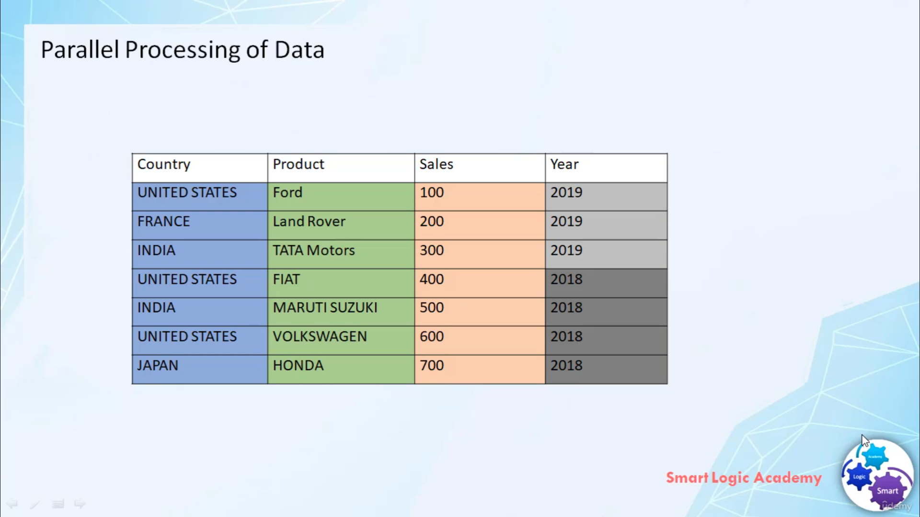

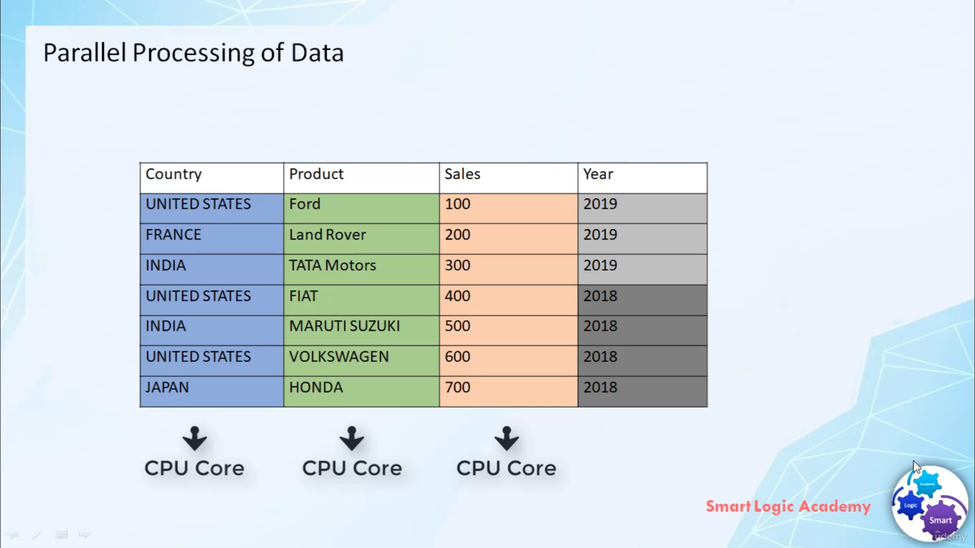

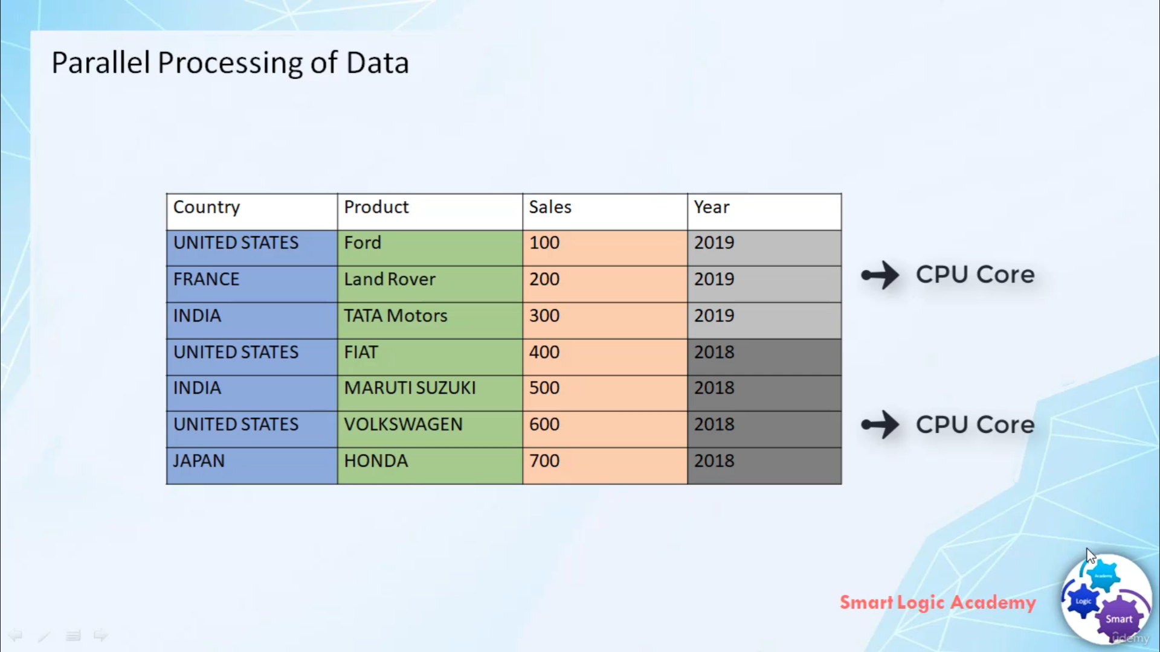

Hi,

welcome back.

In this video, I will tell you about the parallel processing of data in SAP HANA database. One of the

key enabler of SAP HANA's incredible performance is the parallel processing. With recent hardware

development, especially new multi-core processors.

We can build an instant response application by spreading the processing task across all the cores. SAP HANA

automatically spreads the workload across all the cores and ensures that all the parts of hardware are

contributing to the

throughput. SAP HANA is scalable means you can easily add more processors as required to increase the parallelization

and therefore the speed of processing. To take advantage of the built-in prallel processing

capabilities of SAP HANA,

you can use column store table. column store tables are automatically processed in parallel. Each column can

be processed by one core hence more cores you add to the SAP HANA landscape

the more parallelization occurs. Even the same column can be split up and processed by different core

at the same time.

Play

2. What is SAP HANA ?